Task 2 — InstructorSchedule
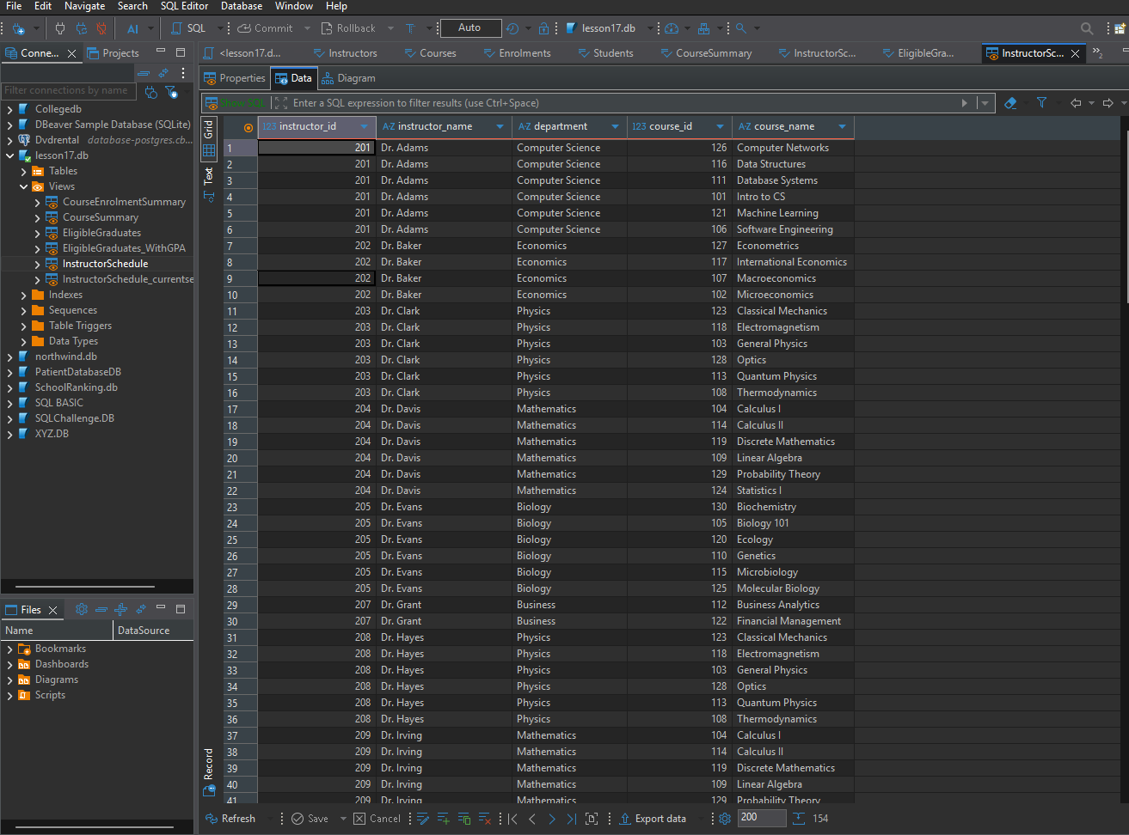
Task 3 — CourseSummary
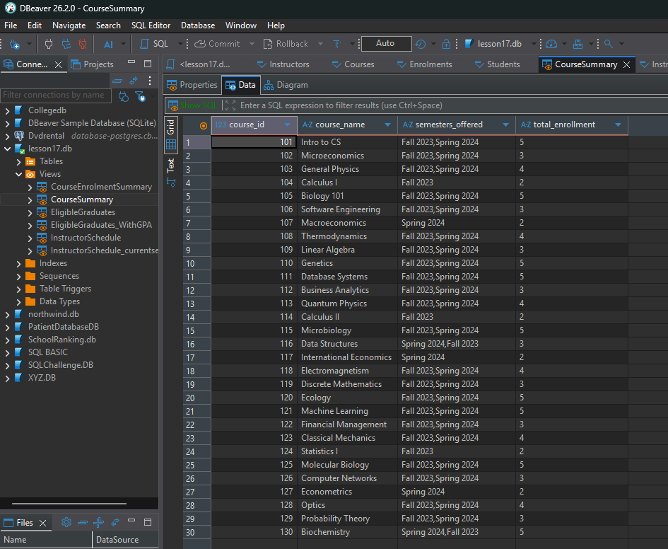
Task 4 — InstructorSchedule_CurrentSemester
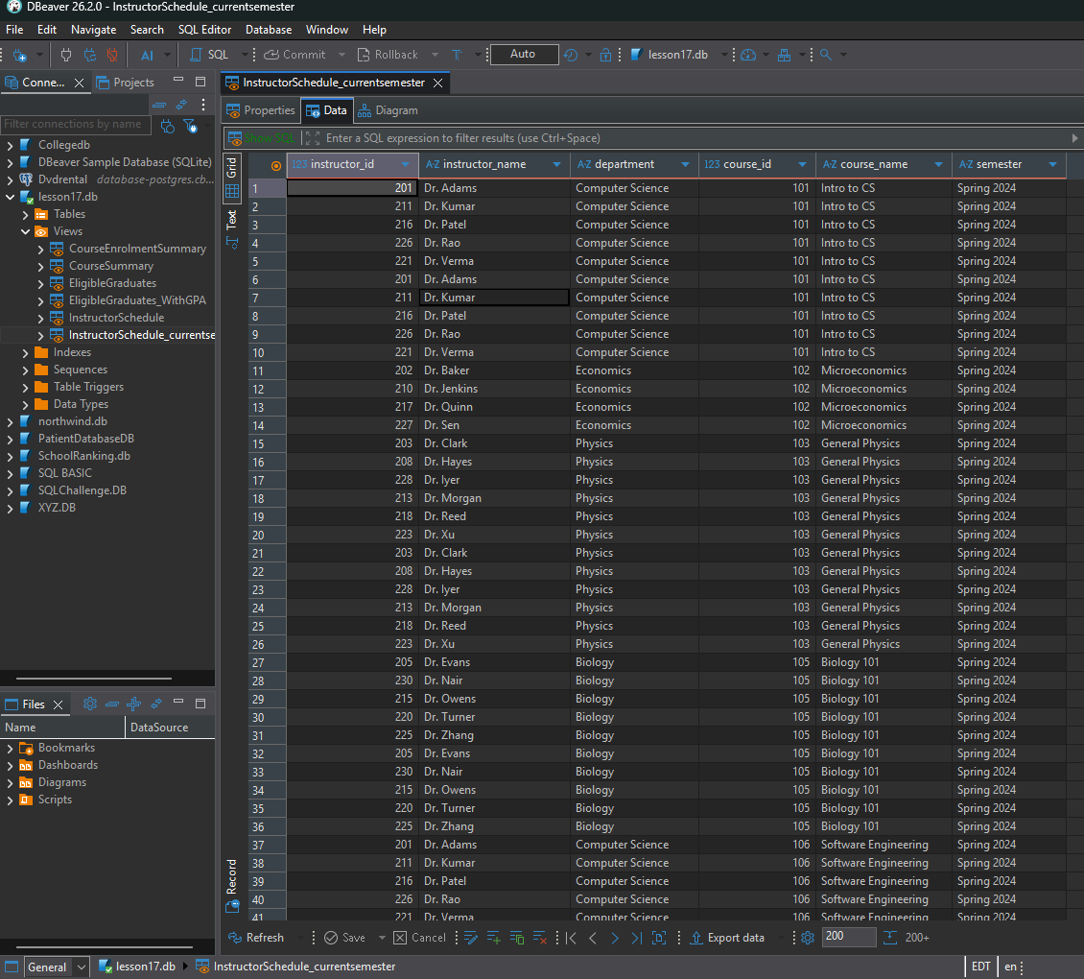
Task 5 — EligibleGraduates
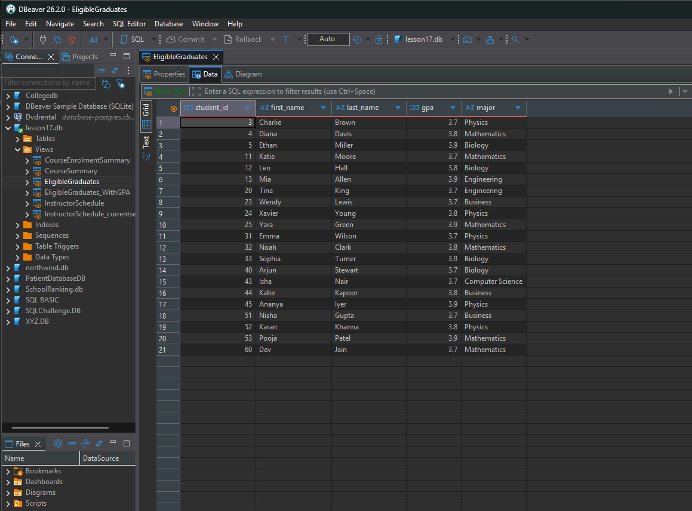
Task 6 — EligibleGraduates_WithGPA
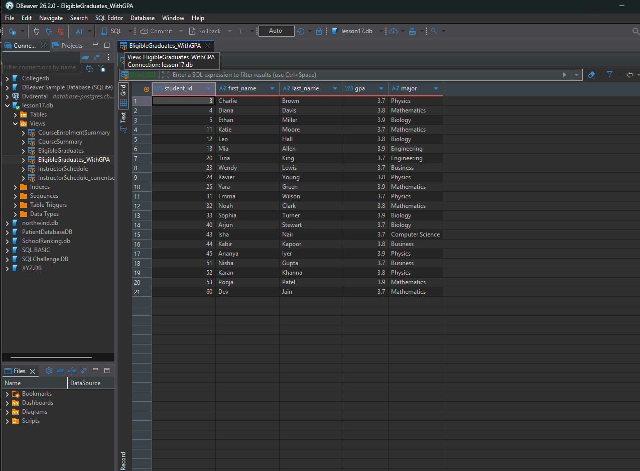
Task 7 — CourseEnrolmentSummary
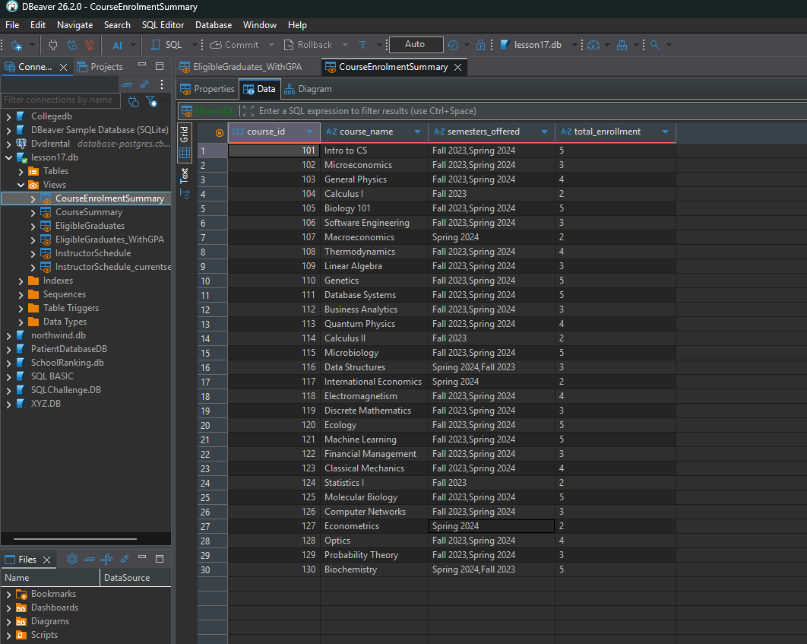
TASK 8 AND 9
